Project Name: Bank Management Application

Date: 01/02/2023

Copyright Notice
This document contains proprietary information of HCL Technologies Ltd. No part of this document may be reproduced, stored, copied, or transmitted in any form or by means of electronic, mechanical, photocopying or otherwise, without the express consent of HCL Technologies. This document is intended for internal circulation only and not meant for external distribution.

Revision History
Version No | Date | Prepared by / Modified by | Significant Changes
Bank application 1 | 24/01/2023 | Sarvagya Singhal | -
Bank application 2 | 01/02/2023 | Sarvagya Singhal | Changes in deposit money, withdraw money, check balance, delete customer modules.

Table Of Contents

1.1 Project Overview 3
1.2 Scope 3
1.3 Out of Scope 3
1.4 Intended Audience 3
1.5 High Level Use Cases 3
1.6 Use Cases detailed 3
1.7 Technical Architecture 3
1.8 Technical Detailed Description 3
1.9 Sequence Diagram 3
1.10 Database Entity Relationship Diagram 3
1.11 Standards 3
1.12 Non Functional Requirements 3

Project Overview

The project is a bank management application that allows users to perform various banking functions such as adding customers, depositing money, withdrawing money, checking balance, and deleting customers. The application is built using Java and uses a MySQL database for storing customer information.

Scope
The application will allow users to perform the following functions:
- Add new customers to the system
- Deposit money into a customer's account
- Withdraw money from a customer's account
- Check the balance of a customer's account
- Delete a customer from the system

Out of Scope
The application will not include any additional banking functions such as loan processing or credit card management.

Intended Audience
The intended audience for this application is bank employees and managers who will be responsible for managing customer information and performing banking transactions.

High Level Use Cases
Actions
Bank

User
Add Customer


Deposit Money

Withdraw Money

Check Balance

Delete a customer

Technical Architecture
The application will be built using Java and will use a MySQL database for storing customer information.

Technical Detailed Description
The application will use Java as the programming language and will make use of JDBC to connect to the MySQL database. The database will store customer information such as name, account number, and account balance, mobile number. The application will also use a user interface to allow bank employees to perform the various banking functions described in the use cases.

Sequence Diagram
User
Bank
Database

Requests to add a new customer Creates a new customer by
Add
Customer
inserting data in the “bank” table

Confirms the addition Confirms the insertion
of a new customer of a new customer

Requests to deposit money Updates the balance of the customer by
Deposit Money
inserting the amount in the “bank” table

Confirms the deposit Confirms the update of the
of money customer’s balance

Requests to withdraw money Updates the balance of the customer by
Withdraw Money
subtracting the amount in the “bank” table

Confirms the withdrawal Confirms the update of the
of money customer’s balance

Show Balance
Requests to check the balance Queries the balance of the
customer from the “bank” table

Confirms the balance of the
customer Returns the balance of the customer

Delete
Customer
Requests to delete the customer. Deletes the customer by removing
the data from the “bank” table

Confirms the deletion of Confirms the deletion of the customer
the customer
Database
User
Bank

Database Entity Relationship Diagram

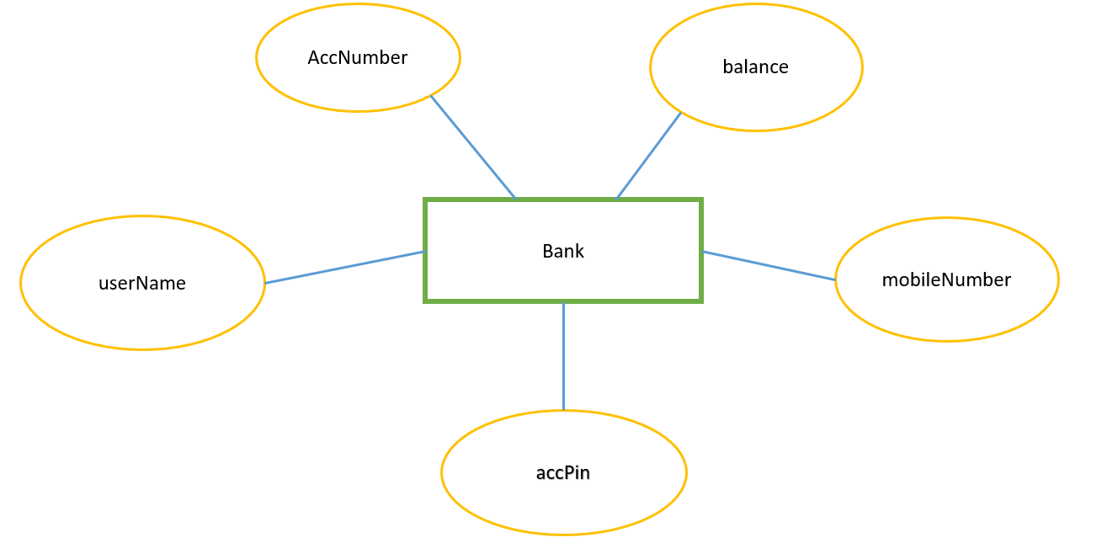

Non Functional Requirements
- Security: The application will need to ensure that customer information is protected and that only authorized users can access it.
- Performance: The application will need to respond quickly to user requests in order to provide a good user experience.
- Scalability: The application will need to be able to handle an increasing number of customers and transactions as the bank grows.

